SACRED HEART PARISH

Sacred Heart Parish Founded 1814, The First Catholic Parish in the STate of New Jersey

Sacred Heart Church, 343 South broad Street, Trenton, New Jersey 08608

Holy Cross Church, 233 Adeline Street, Trenton, New Jersey 08611

ALL ARE WELCOME

Whatever your present status in the Catholic Church, whatever your current family or marital situation,

Whatever your past or present religious affiliation, whatever your personal history, age, background, or

race, whatever your own self-image or esteem, you are invited, welcomed, accepted, loved and

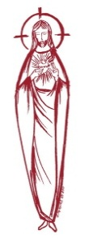
respected at the Parish of the Sacred Heart.

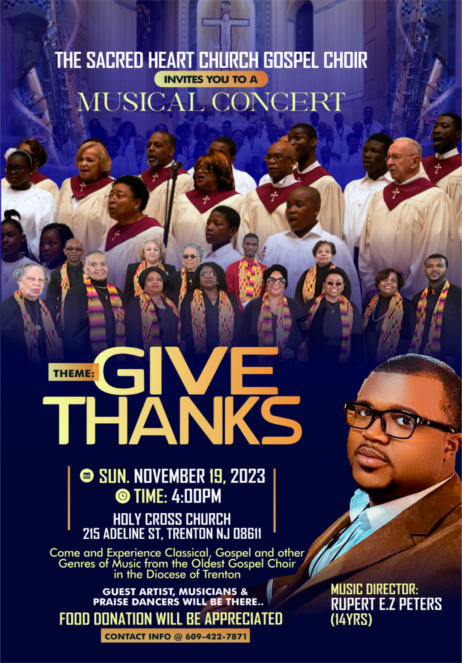

Sacred Heart Gospel Choir will host a musical concert, “Give Thanks,” Nov. 19 at 4 p.m. in Holy Cross Church, 215 Adeline St. Under the direction of Rupert Peters, the concert will feature various genres of music including classical and Gospel. Guest artists, musicians and praise dancers will also be involved. Attendees are asked to contribute a food item for the parish food pantry.
For more information, call 609-422-7871.

THIRTY-THIRD SUNDAY IN ORDINARY TIME
NOVEMBER 19, 2023
MASS INTENTIONS
Saturday, November 18
4:00pm ~ William Friedman Sr & William Friedman Jr
5:15 pm SHC ~ Dorothy Solack
Sunday, November 19
9:00 SHC ~ Juan Ortiz and Daniel & Jean Ridorfino
10:00 HCC ~ Intentions of the People of the Parish
11:15 SHC ~ Patrick Woodhead
12:00 HCC Polish ~ Stanley Tylutki
Monday, November 20
8:00 am HCC ~ Diana Cracker Amoroso
12:10pm SHC ~ Carl Amoroso
Tuesday, November 21
12:10 pm SHC ~ Antonio Chiaromonte
Wednesday, November 22
12:10 pm SHC ~ Philomena & William Cracker
Thursday, November 23 ~ Thanksgiving
9:00 am SHC ~ Mass of Thanksgiving for our Parishioners
Friday, November 24
8:00 am HCC ~ No Mass
12:10pm SHC ~ No Mass
Saturday, November 25
4:00pm~ Dcn. John Grussler & Stanley Saganowski Jr.
5:15 pm SHC ~ Brenda Southwick & Rita Mich
Sunday, November 26
9:00 SHC ~ All Souls Intentions
10:00 HCC ~ Intentions of the People of the Parish
11:15 SHC ~ Salvatore Ferrara and Ferrara Family
12:00 HCC Polish ~ Stanley Tylutki

OUR SICK LIST
Susan Cuniglio, Mary Sokolowski, Rocco, Robin Haynes, Lorraine Wargo, Robert Paci, Mrs. Loatman, David Carver, Jennifer Lyons, Grace Profy, Steve Jurczynski, Cornell Hess, Ruby Covington, Judith Santigo, Ching Kukis, Dan Breese Jr, Brenna Kennedy-Moore, Dawn Chia, Mark Friedman, Alexander A. Ladnyk, Kelly Nitti, Lauren Clayton, Joseph Edralin, Margie Tiongson, Kevin, Vincent Cooper, Jr., Gail Ladnyk, Leo Genovesi, Sloane Donnelly, Richard Buckley, Tony Ragolia, Barbara Burrows, Charles Burrows, Dorothy Amoroso, Maryann Sullivan, Regina Friedman, Stanley Winowicz, Greg Schafer, Jack Hardiman, Amy Birk, Julia Grazioli, Matt Tydryszewski.
OUR DECEASED
Carmella Staub, Nugent Calcagni Jared Fowler, Josephine Southwick, Cecelia G. Watson, Fr. Joseph Radomski, a priest of our Diocese, and our friends at South Village, Riverside Nursing and Rehabilitation Center, Mill House and Waters Edge.

MINISTRY SCHEDULE
(subject to change)
Saturday, November 18
4:00pm HCC ~ Fr Charles L. C. Benitez Em. L. Bliznawiczus
5:15pm SH Msgr. Dennis L. L Seabrook Em. W. Lewis & M. Salamandra
Sunday, November 19
9:00 SH Msgr. Dennis L. Y. Laurenti Em. K. Jurczynski & M. Komjathy
10:00 HCC ~ Fr. Charles L. I. Nwachukwu Em. S. Nwachukwu
11:15 SHC ~ Msgr Dennis L. M. Rhodes Em. L. & J. Silvernail
12:00 HCC Polish ~ Fr Charles Anna, Danuta.

Saturday, November 25
4:00pm HCC ~ Fr Charles L. R. Micharski Em. C. Benitez
5:15pm SHC ~ Msgr. Dennis L. K Willever Em. J. Breuer B DuMont
Sunday, November 26
9:00 SH Msgr. Dennis L. K. Jurczynski Em. H. Mangan & J. McDonough
10:00 HCC ~ Fr. Charles L. M. Williams Em. A. Lennon
11:15 SH Msgr Dennis L. M. Tovar Em. M. Ortiz &. T. Rizzuto
12:00 HCC Polish ~ Fr Marian

WEEKLY COLLECTION
Last weekend’s collection amounted to $7,683.00. This includes the donations received in Church and the mail ins. Thank you for your continued support of our parish.

2023 ANNUAL CATHOLIC APPEAL UPDATE
Goal: $33,000.00 :
Pledged: $46,427.00 (141% of Goal)

READINGS FOR THE WEEK
Thirty-third Week in Ordinary Time
Sunday Prv 31:10-31; 1 Thes 5:1-6; Mt 25:14-30
Monday 1 Mc 1:10-15, 41-43, 54-57, 62-63; Lk 18:35-43
Tuesday 2 Mc 6:18-31; Lk 19:1-10
Wednesday 2 Mc 7:1, 20-31; Lk 19:11-28
Thursday “In Thanksgiving to God”
Friday 1 Mc 4:36-37, 52-59; Lk 19:45-48
Saturday 1 Mc 6:1-13; Lk 20:27-40

PROMISE TO PROTECT
The Diocese of Trenton is committed to the norms of the U.S. Bishop’s Charter for the Protection of Children and Young People in regard to the reporting and investigation of sexual abuse allegations involving minors. If you have been sexually abused as a minor by anyone representing the Catholic Church, you can report that abuse through the diocesan Hotline: 1-888-296-2965 or abuseline@dioceseoftrenton.org. Allegations are reported to the appropriate law enforcement agencies.
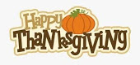
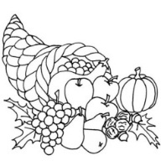
THANKSGIVING FOOD
BAGGING AND DISTRIBUTION
Food bagging this month is scheduled for Monday, November 20th at 9:30 am. The Food Distribution is on Tuesday, November 21st beginning at 1:30. Your help is greatly needed to prepare 400 bags for our neighbors. Thank you.

THANKSGIVING DAY
Please join us as we celebrate Thanksgiving with a con-celebrated Mass at 9:00am in Sacred Heart Church. The Parish Office will be closed on November 23rd and 24th and Mass will not be celebrated on Friday at 8:00 AM and 12:10 noon.
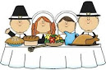
Thanksgiving Table Prayer
Lord God, our hearts are crowded with gratitude as we celebrate the
feast of Thanksgiving.
We have come to this our feasting table with great joy and eagerness, for we are truly grateful to You, our God,
for all that we have been given.
We pause now and, in silent prayer, do thank You for the great generosity of Your gifts.
(pause for silent prayer)
We also thank one another for the gifts of love and affection that we have
freely shared.
We are thankful for all who are present at this our feast
(names of guests may be mentioned)
as well as for those who have labored in love in order to bring this dinner to our table.
May You, our God, bless this Thanksgiving feast and all of us who shall share it in Your holy name: Father, Son and Holy Spirit. Amen

OUR GIVING TREE PROJECT
BEGINS THIS WEEKEND

HOW IT WORKS
There are 300 hundred Star tags on our Christmas Giving Trees this year. Each tag represents an individual who has requested a specific gift. All gifts are due back on the weekend of December 9th/ 10th The color of the tag indicates the agency to receive the gift. Please wrap the gift and secure the tag to the gift. All gifts will be picked up by the agencies on Monday morning December 11th . Please, if you take a tag, we ask that you return the gift. No gift should be more than $25.00. Thank you for sharing your Christmas Joy with the needy in our greater Trenton area.

The recipients of our Giving Tree this year are:
1) El Centro housed in the former convent on the campus of Sacred Heart Parish, El Centro, a program of Catholic Charities, Diocese of Trenton, has for more than 20 years been a source of basic necessities to education and long-term development for anyone who walks through its doors.
2) Kingsbury is a Non-Profit organization dedicated to providing housing in the greater Trenton Area. The commanding Twin Towers apartment buildings on Market Street initiated by Kingsbury for close to 50 years.
3) Mt Carmel Guild founded in 1920, is located at 73 North Clinton Avenue to form headquarters for the Mount Carmel Guild. For more than 100 years, Mount Carmel Guild has served poor and needy people of Mercer County.
4) The Catholic Youth Organization (CYO of Mercer County) is a public benefit community organization that enhances the lives of Greater Mercer County youth and their families, by providing affordable, quality, educational and recreational services. Rooted in the Catholic Tradition, the CYO provides these services in an inclusive and non-discriminatory manner respecting the culture and faith of all.
5) Haitian Community of the Diocese of Trenton, based in Our Lady of Sorrows – Saint Anthony Parish, provides appropriate pastoral and social services to Haitian immigrants.

HUMAN DEVELOPMENT
The annual Catholic Campaign for Human Development (CCHD) collection will take place this weekend, November 18 and 19. For over 50 years, CCHD has been working in partnership with community organizations to address the root causes of poverty in the United States. CCHD promotes organizations that help people help themselves, and their mission to break the cycle of poverty is now more important than ever. CCHD organizations are responding promptly to this time of extraordinary need. CCHD grantees create jobs, improve neighborhoods, keep schools safe and enriching for children, and raise leaders of the future right here in our state. CCHD is very thankful for your support thru the second envelope for our collection this weekend..
THE MIRACLE OF CHRISTMAS
SIGHT AND SOUND, LANCASTER
Our Seniors Group has planned a bus trip for Friday, December 29, 2023, to the Sight and Sound Theatre in Lancaster, PA to see “The Miracle of Christmas”. The bus will leave Sacred Heart Church parking lot at 8:00 am and return by 6:30 pm. The cost of $150.00 per person includes transportation and gratuity, mid-afternoon lunch at Bird-In-Hand Restaurant and the 11:00 morning show ticket. A non-refundable deposit of $75.00 is required to make a reservation. Final payment is due by December 1st. Reservations can be made for non-parishioners at the cost of $165.00 paid in full. Checks are made payable to Sacred Heart Parish. To make a reservation, please contact Pat McIntyre at PatriciaMc@optonline.net or 609-695-5391.

OUTDOOR NATIVITY SET UP
We need your help on the Saturday after Thanksgiving, November 25th to set up the outdoor Nativity scene at 9:00 am in front of the rectory at the Sacred Heart Campus. Please give us an hour or so of your time to help prepare for the Christmas season. On Monday the 27th of November we will set up the outdoor Nativity in front of the Church on the Holy Cross campus at 10:00 am, your help is needed to prepare our grounds for the Christmas Season.
PLANNING AHEAD

GIVING TREE
We are trying something different with the Giving Tree project this year, that is our beginning date is earlier than usual. We will begin on the weekend of November 18th and 19th and gifts are due on
December 10th.

ADVENT MEDITATION BOOKLETS
The Magnificat Advent Companion devotional booklets will arrive in time for the beginning of the Advent Season. Please take one per family.

2024 CALENDARS
Our 2024 Calendars have arrived and will be available beginning the first weekend of December in the vestibule of our Churches.

MILL HILL HOUSE TOUR
Holiday House and Window Tour
The House Tour is Mill Hill’s signature event and a Trenton tradition. This year’s tour will take place from 12 noon to 5:00 p.m. on Saturday, December 2, 2023. For ticket please visit: www.TrentonMillHill.org Our Sacred Heart Church is once again on the tour.

CAPITAL SINGERS OF TRENTON
Concert December 3rd at 4:00
Winter Songs XVI in Sacred Heart Church

ADVENT PENANCE SERVICE
Our parish will join our neighboring parishes at Our Lady of Good Counsel, Ewing, December 9th at 10:00AM for our Advent Penance Service.

OPLATKI
Oplatki, the traditional Polish Christmas Wafer can be ordered any Church Supply store but here are two suggestions: Christmas Wafers Bakery, P O Box 99, Lewiston, New York 14092 – 0099. Phone 716-283-8911 christmaswafersbackery@gmail.com
OR
Saint Jude Shop, 21 Brookline Blvd.
Havertown, PA 19083

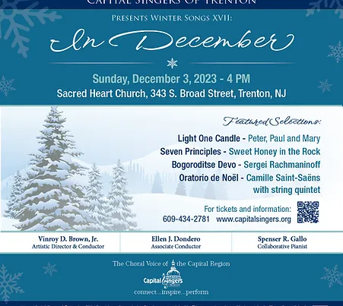
CHRISTMAS SCHEDULE 2023

SACRED HEART CHURCH
Saturday, December 23
5:15 PM Vigil Mass
Sunday, December 24
10:00 AM
The Nativity of the Lord ~ CHRISTMAS EVE
4:15 PM Christmas Presentation
in Word and Song
5:15 PM and 12:00 Midnight Mass
Monday, December 25 ~ CHRISTMAS DAY
9:00 AM and 11:15 AM
Tuesday, December 26 No Mass

HOLY CROSS CHURCH
Saturday, December 23
4:00 PM Vigil Mass
Sunday, December 24
10:00 AM and 12:00 Noon Polish
The Nativity of the Lord ~ CHRISTMAS EVE
4:00 PM
Monday, December 25 ~ CHRISTMAS DAY
10:00 AM Gospel and 12:00 Noon ~ Polish

ALTAR ROSARY SOCIETY
All future people of our parish are warmly welcomed to join us on Sunday, December 3, 2023, 9:00 am Mass celebrated at Sacred Heart Church. The Rosary will be prayed before Mass. Following Mass a meeting will take place at Toomey Hall. Come meet the members and enjoy light refreshments. We are a group of dedicated Catholic people who serve our Blessed Mother, our Parish. We always look forward to your participation. Wishing everyone a Blessed, healthy, safe, Christmas Season. Any questions, please call Joan Buckley at 609-396-7063.

RELIGIOUS EDUCATION
November 19 – Thanksgiving Family Mass at 11:15 Mass
December 26 – NO Class for
Thanksgiving holiday

PRAYER IN TIME OF BEREAVEMENT
O Jesus, who wept at the death of your friend and taught that they who mourn shall be comforted, grant us the comfort of your presence in our loss. Send Your Holy Spirit to direct us lest we make hasty or foolish decisions. Send Your Spirit to give us courage
lest through fear we recoil from living.
Send Your Spirit to bring us your peace
take root in our hearts. The Lord has given.
The Lord has taken away.
Blessed be the name of the Lord.
Amen.

CONGRATULATION
To our own Bishop David M. O’Connell, C.M. the newly named Chairman-Elect of the Committee on Catholic Education for the USCCB. You have our prayers and support as you bring your more than 40 years of ministerial experience in Catholic education to this national post.
We are so very proud of you.

ST. ANDREW DUNG-LAC AND COMPANIONS
Andrew Dung-Lac, a Catholic convert ordained to the priesthood, was one of 117 people martyred in Vietnam between 1820 and 1862. Members of the companions group gave their lives for Christ in the 17th, 18th, and 19th centuries, and received beatification during four different occasions between 1900 and 1951. All were canonized during the papacy of Saint John Paul II. Christianity came to Vietnam through the Portuguese. Jesuits opened the first permanent mission at Da Nang in 1615. They ministered to Japanese Catholics who had been driven from Japan. Severe persecutions were launched at least three times in the 19th century. During the six decades after 1820, between 100,000 and 300,000 Catholics were killed or subjected to great hardship. Foreign missionaries martyred in the first wave included priests of the Paris Mission Society, and Spanish Dominican priests and tertiaries. In 1832, Emperor Minh-Mang banned all foreign missionaries, and tried to make all Vietnamese deny their faith by trampling on a crucifix. Like the priest-holes in Ireland during English persecution, many hiding places were offered in homes of the faithful. Persecution broke out again in 1847, when the emperor suspected foreign missionaries and Vietnamese Christians of sympathizing with a rebellion led by of one of his sons. The last of the martyrs were 17 laypersons, one of them a 9-year-old, executed in 1862. That year a treaty with France guaranteed religious freedom to Catholics, but it did not stop all persecution. By 1954, there were over a million Catholics—about seven percent of the population—in the north. Buddhists represented about 60 percent. Persistent persecution forced some 670,000 Catholics to abandon lands, homes and possessions and flee to the south. In 1964, there were still 833,000 Catholics in the north, but many were in prison. In the south, Catholics were enjoying the first decade of religious freedom in centuries, their numbers swelled by refugees.
During the Vietnamese war, Catholics again suffered in the north, and again moved to the south in great numbers.

NATIVE AMERICAN HERITAGE DAY HISTORY
Dr. Arthur C. Parker of the Seneca nation first protested for National Native American Heritage Day between 1912 and 1915. At first, he was fighting for an “American Indian Day” to be recognized within the Boy Scouts of America. In 1990, President George H. W. Bush signed into law the legislation introduced by Congressman Joe Baca, to designate the day after Thanksgiving as American Indian Heritage Day. The law was established on November 28 as a day to pay respects to the Native Americans for their numerous contributions to the United States. The American Indian Heritage Day was supported by the National Indian Gaming Association (NIGA) and 184 federally recognized tribes.

The Native American Heritage Day encourages Americans of all backgrounds to appreciate the indigenous cultures appropriately, with ceremonies and activities. Schools are also encouraged to enhance their students’ awareness of Native Americans by providing classroom activities focused on their history, contributions, and achievements.

The United States House of Representatives initially passed the Native American Heritage Day Act of 2009, with technical adjustments made by a collective consent in the United States Senate. The House of Representatives unanimously voted to pass the legislation again, including the Senate’s adjustments. The legislation was then signed into public law by President Barack Obama on October 30, 2009.

Native American Heritage Day and Month is a huge platform for Indigenous people to educate society about their communities. On this day, more than ever, they lead the discourse on culture, celebrate their heritage by donning traditional footwear (“rocking the moccasin”), and shed some light on the diverse tribal communities.

